**Assignment 4**

**Write a query to get unique department ID from employee table :**

SELECT DISTINCT DEPARTMENT_ID FROM employees;

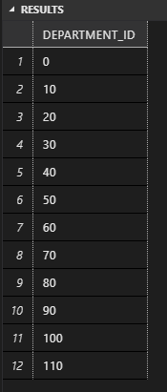

**Write a query to get all employee details from the employee table order by first name, descending:**

SELECT * FROM employees

ORDER BY FIRST_NAME DESC;

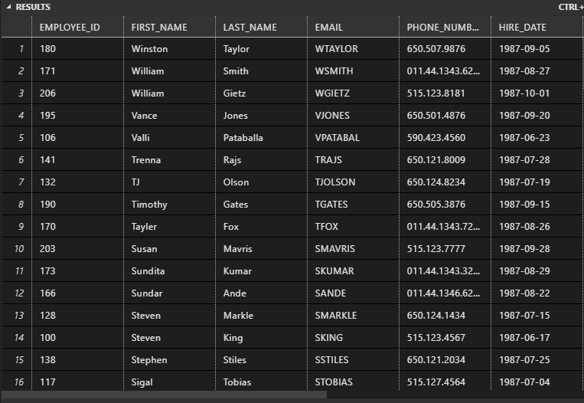

**Write a query to get the employee ID, names (first_name, last_name), salary in ascending order of salary.**

SELECT EMPLOYEE_ID,FIRST_NAME,LAST_NAME,SALARY

FROM employees

ORDER BY SALARY ASC;

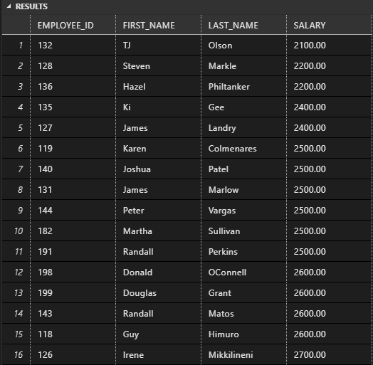

**Display first name and join date of the employees who is either IT Programmer or Sales Man.**

SELECT FIRST_NAME, HIRE_DATE FROM employees

WHERE JOB_ID = 'IT_PROG' OR JOB_ID = 'SA_REP';

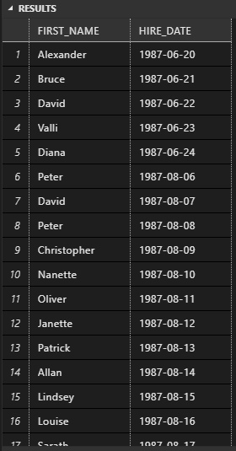

SELECT * FROM employees

WHERE EMPLOYEE_ID = 150 OR EMPLOYEE_ID = 160;

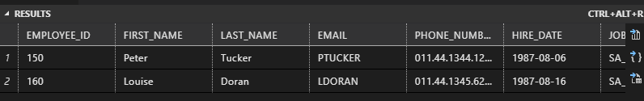

**Display first name, salary, commission pct, and hire date for employees with salary less than 10000.**

SELECT FIRST_NAME, SALARY, COMMISSION_PCT, HIRE_DATE FROM employees

WHERE SALARY < 10000;

**Display employees where the first name or last name starts with S:**

SELECT FIRST_NAME,LAST_NAME FROM employees

WHERE FIRST_NAME LIKE 'S%' AND LAST_NAME LIKE '%S';

**Display details of the employees where commission percentage is null and salary in the range 5000 to 10000 and department is 30.**

SELECT * FROM employees

WHERE COMMISSION_PCT = 0 AND (SALARY BETWEEN 5000 AND 10000) AND DEPARTMENT_ID = 30;

**Display employees first_name,email who are working in “Executive” department.**

SELECT FIRST_NAME,EMAIL

FROM employees

FULL OUTER JOIN departments

ON employees.DEPARTMENT_ID = departments.DEPARTMENT_ID

WHERE DEPARTMENT_NAME = 'Executive';

**Display unique contry_id from locations table.**

SELECT DISTINCT country_id FROM locations;

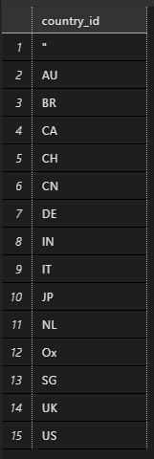

**Display all employees whose have job_id IT_PROG and FI_ACCOUNT**

SELECT * FROM employees

WHERE JOB_ID = 'IT_PROG' OR JOB_ID = 'FI_ACCOUNT';

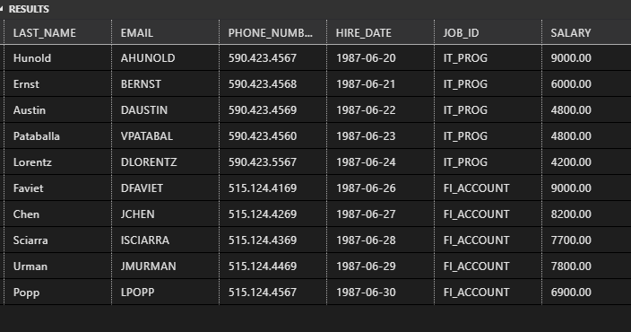

**Display all countries in ascending order:**

SELECT country_id FROM locations

ORDER BY country_id ASC;

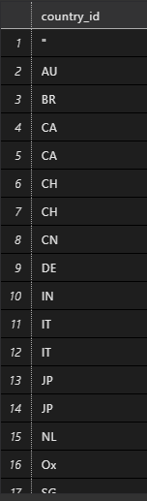

**Display details of jobs in the descending order of the title:**

SELECT * FROM JOBS

ORDER BY JOB_TITLE DESC;

